- Google search “Transpose extension”
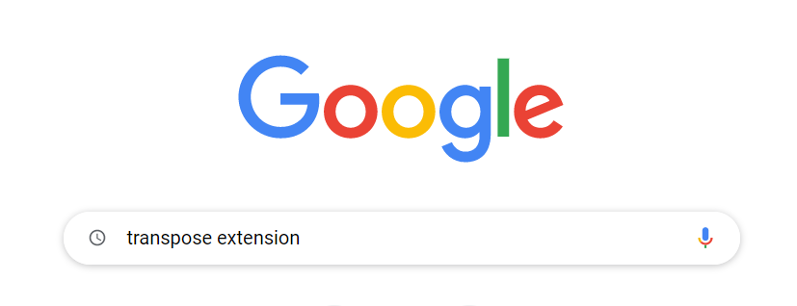
- Find appropriate link (Should look something like below)
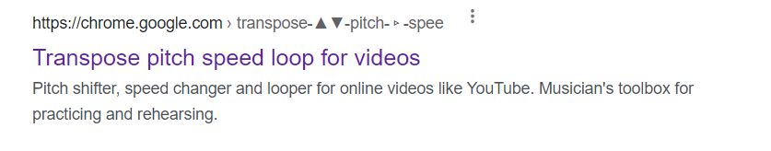
- Click the link
- Add it to Chrome (click “add to Chrome”)
- Click “Add Extension”
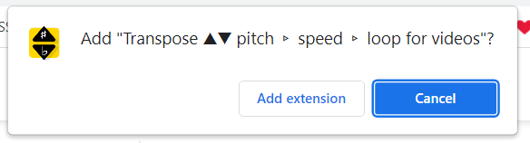
- Click the button below to install
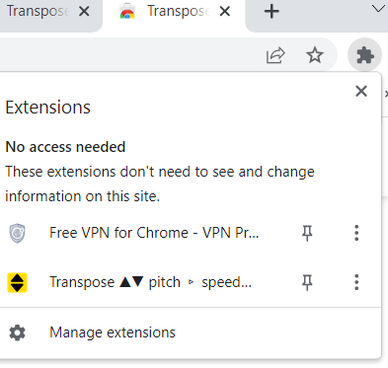
- Install it

This extension allows you to change the pitch and/or the tempo of any video recording. It also allows you to make a loop, so that you can practice a section of the video, say a piece, over and over again without needing to press any more keys between each time you repeat.

Transpose ▲▼ pitch ▹ speed ▹ loop for v...

If you don’t use Google Chrome, Here's an article which explores other options
Top 7 Video Speed Controller Extensions for Chrome/Firefox/Safari

Top 7 Video Speed Controller Extensions...

